What you need to know

Does my child really need one?
The simple answer is yes. Laws now require helmets in many areas. That is because research shows that a bicycle helmet can prevent most cyclist head injuries. Nearly 700 bicycle riders are killed in the U.S. every year, almost all in collisions with cars, and most die of head injuries. Many thousands more suffer less severe but still debilitating injuries that are far worse than the physical pain of scraped skin or even broken bones. Your child can suffer permanent personality changes and learning disabilities from a brain injury, and both of you will be aware of what they have lost. Common long-term effects include concentration difficulties, aggressiveness, headaches and balance problems. Imagine a parent’s anguish if this happens to their child.
What will it cost?
Helmets sell in bike shops from $25 up, or in discount stores for $10 and up. A good shop helps with fitting, important for safety. Lab tests show that the impact performance of the cheapest helmets equals that of the most expensive ones. Helmets are cheap for their benefit, so don’t wait for a sale.
Need a new one every year?
No. Heads grow less than legs and feet. Many child helmets come with two or even three sets of foam fitting pads. and some have adjustable ring-fit.

.
Will my child actually use it?
Yes, if other children wear one, their parents use one, the teacher at school has told them how much good helmets do, and the child has picked out the one they really want. No, if the helmet makes your child feel like a geek, nobody else uses one and it does not fit well. Perhaps yes if you have the will to enforce the rule. Most situations fall somewhere in between, and you know your child best. Seventh grade seems to be the most resisting age for helmets, when the feeling of invincibility is strong and the rage for fashion is undeniable. The key motivator of helmet use for kids is fashion, not safety. Try to make use of that.
Does a Toddler Need a Helmet?
A child of any age needs head protection when riding, but a toddler's neck may not support the weight of a helmet. For this and other reasons, nobody in the injury prevention community recommends riding with a child under one year old. If in doubt, take child and helmet to a pediatrician for advice. Child helmets need ventilation in hot weather, since the foam holds heat in. Toddler heads vary in shape, so pay careful attention to fit.
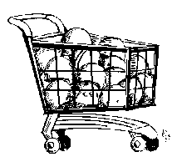
What about standards?
All helmets sold in the U.S. must meet the US Consumer Product Safety Commission CPSC standard and state that on a sticker inside. Fit is not tested by the standards, so you have to try the helmet on your child’s head.
Which one should I buy?
There are many good helmets on the market. Consumer Reports has some recommendations. We think Bell’s discount line of True Fit system helmets are easy to fit. Some models now have new technology inside attempting to reduce rotational energy in a crash, and may help in some situations. But since the impact performance is legally regulated, you can choose based on how well a helmet fits your child and which one your child likes. A discount helmet will be equally protective if you take the time to fit it carefully on your child.
How to Buy
Guide your child to pick a helmet with a smooth shell in a bright color. Check for a pinch-proof buckle. Put it on your child, adjust the straps and pads or the inner one-size-fits-all ring, and then make sure it will not come off.

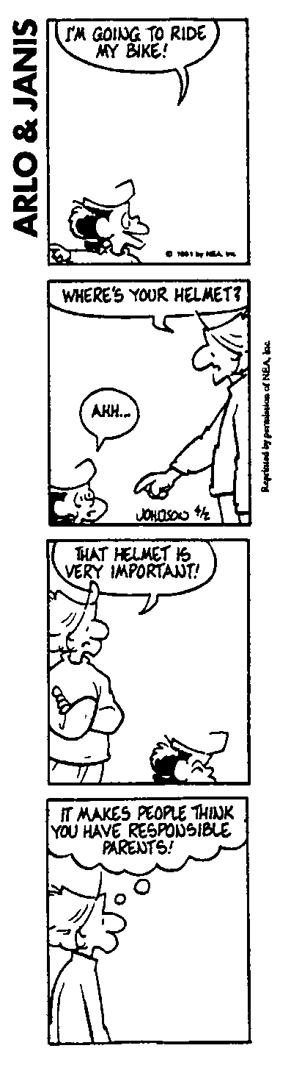
First, A Chuckle
When to Replace a Helmet?
Replace any helmet when your child crashes in it. Impact crushes some of the foam. The helmet is less protective although the damage may not be readily visible. Helmets soften impact, so the child may not even be aware that their head hit until you examine the helmet for damage. Replace the buckle if it cracks or if any piece of it breaks off. Nobody prompts you to replace your child’s helmet, so give it some thought.
Bike Helmets for Other Sports?
Standards for biking include inline skating. There is no standard for tricycle or scooter helmets, but CPSC says bicycle helmets work well for them. Aggressive extreme trick skating and skateboard helmets have a different ASTM standard, for multiple hits but lesser impacts. Most bike helmets are not made for that, although a few of them are. Skate helmets may not meet bike helmet requirements unless they have a CPSC bike standard sticker inside. Helmets for equestrian sports have a unique design to resist a horse's hoof.
Warning: No Helmets on Playgrounds!
In 1999 the first US death involving a bike helmet catching on playground equipment occurred. There have been other near misses. Be sure your children remove their helmets before using playground equipment or climbing trees!
Bicycle Helmet Safety Institute
4611 Seventh Street South
Arlington, VA 22204-1419 USA
703-486-0100 info@helmets.org www.helmets.org
Volunteers funded by consumers, not the industry.
Illustrations by Keri Caffrey (front) and Nancy Olds.
©BHSI, 2024 Permission granted to reproduce on paper for non-profit use.

A
Bicycle Helmet
For My Child

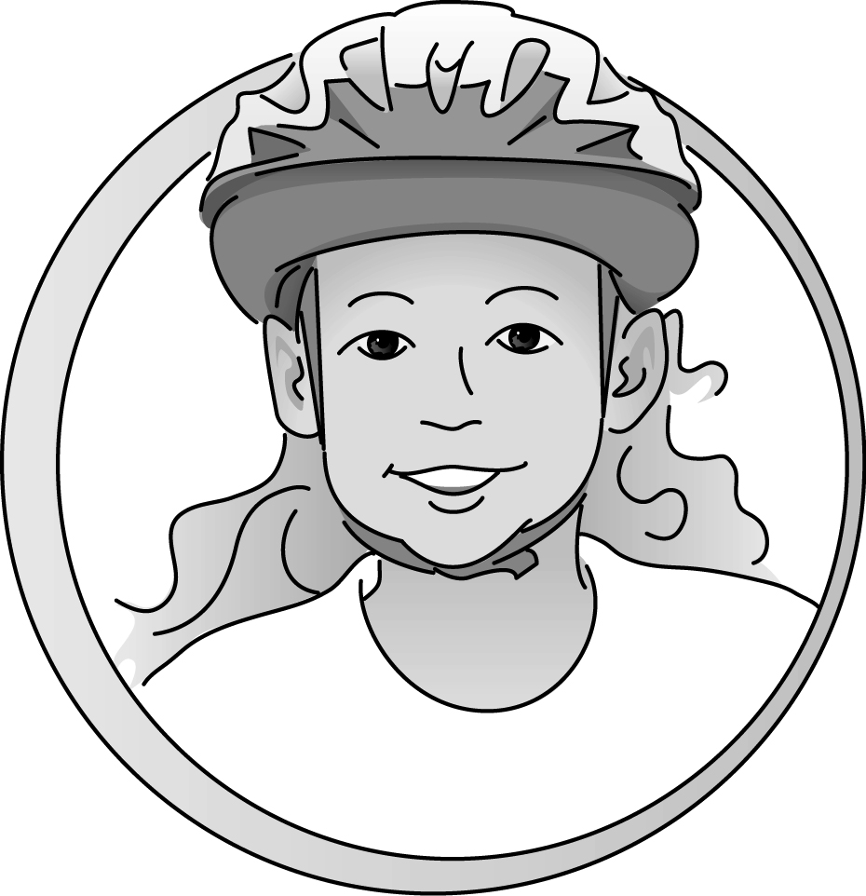

Bicycle Helmet Safety Institute
Cconsumer-funded
helmets.org

