**The Six Minute Guide**

Need One?

Yes! You need your brain to work so you can ride your skateboard, and don’t just lie in bed and slobber the rest of your life. You don’t know how hard pavement is until your head really hits it. If you do a wrist or an arm or a collarbone it heals while your life goes on, but the brain is different. Besides that, helmets may be the law in your area, and you can’t use most skate parks without one.

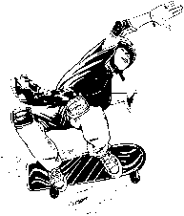

What to Look For

A skateboard helmet softens the impact when the foam inside gives or crushes. The hard shell on most skateboard helmets holds up under multi impacts. Bike helmets use thin plastic that breaks immediately the first time you hit hard.

The best interior foam for skateboard is probably a dual-density liner with a layer of less-dense foam. Or Expanded PolyPropylene (EPP) that looks like bike helmet foam, but recovers for the next hit. There are new liner materials that may be better. Some helmets have a layer inside like MIPS, possibly reducing concussion-level energy.

The helmet must stay on your head. It’s not a hat, just sitting there. It can fly off while you are flying through the air. So it needs a strong strap and buckle. And you need to remember to fasten it.

Skateboard helmets are often black or a dark color. If you want to be seen on the street, get a bright color.

CRW00001

Standards

A sticker inside the helmet tells what standard it meets. True skateboard helmets meet ASTM F1492. Some “skate-style” helmets only meet the CPSC bicycle helmet standard. Those are bike helmets, not skateboard helmets, even if they put a skateboard on the box.



How to Buy

The best skateboard helmets are “dual-certified” to both the ASTM and CPSC standards. For the latest list, check out helmets.org/dualcert. Those helmets are designed for skateboarding and bicycling. But always look inside for the stickers that say they meet both CPSC and ASTM F1492 standards. Without the stickers, they don’t meet the standards!

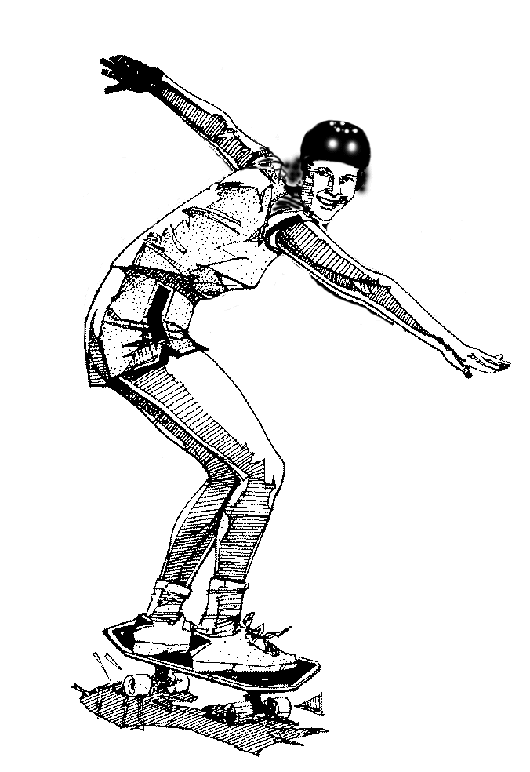

The Two Minute Summary

1. You always need a helmet when you board. You will crash eventually.
2. Even a low-speed fall can scramble your brains.
3. Laws in some states and skateboard parks require helmets.
4. Buy a skateboard helmet for skateboarding, not a bicycle helmet. You will get better coverage and protection built for skateboarding.
5. Skateboard helmets should meet the ASTM F1492 skateboard helmet standard.

If you have 6 more minutes, read on!

skatebd1

When to Replace a Helmet?

If you really have a skateboard helmet that meets the ASTM F1492 standard you don’t need to replace it every time you crash, but after some good hits you will. Bike helmets must be replaced after every crash. Replace the buckle if it cracks or a piece breaks off.

Skate Helmets for Biking?

Do not use a skate helmet for bicycling unless it has a CPSC bicycle helmet standard sticker inside!

Bicycle Helmet Safety Institute

4611 Seventh Street South

Arlington, VA 22204-1419 USA

703-486-0100

info@helmets.org www.helmets.org

Volunteers funded by consumers, not the industry.

©BHSI, 2024 Permission granted to reproduce on paper for non-profit use.

**Skateboard**

**Helmets**

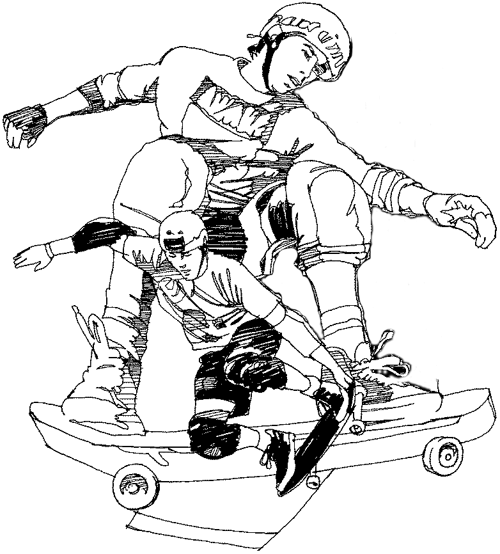

**helmets.org**